Analyst ExCEL ODBC Setup

Contents

Configuration Setup for ODBC Driver 2

Steps to setup the connection and fetch data in Excel. 6

# Configuration Setup for ODBC Driver

1. Search “odbc” on windows search box as shown below and open ODBC Data Source Administrator.

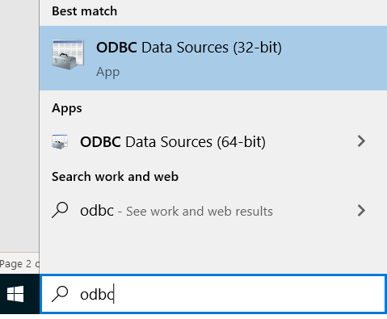

1. Follow the below steps to configure the Data Source. Choose “ODBC Driver 17 for SQL Server” from the options.

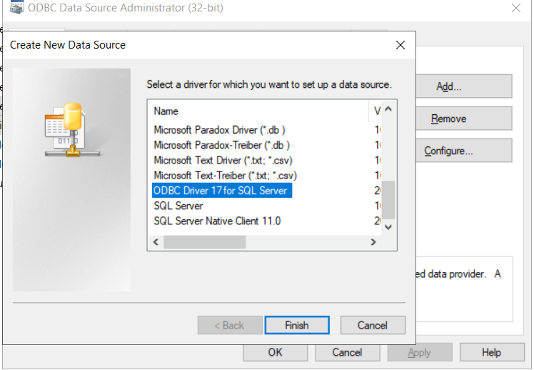

1. Provide the name and Database Server details as shown below and follow the workflow steps by clicking Next buttons.

Name: AnalystExcelODBCPROD  
Desc: AnalystExcelODBCPROD  
Server: KL02WSODB\CLO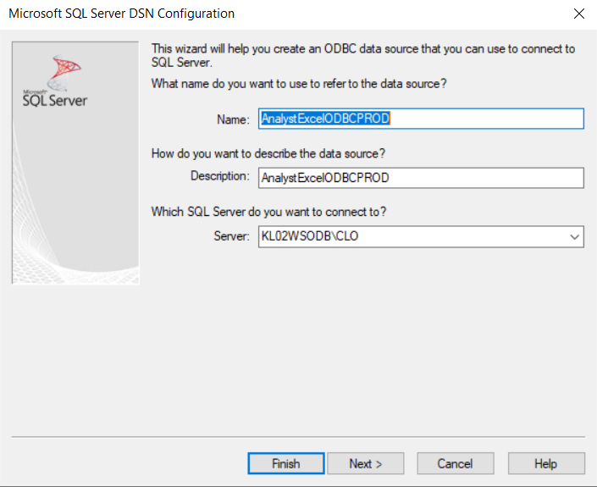  
  
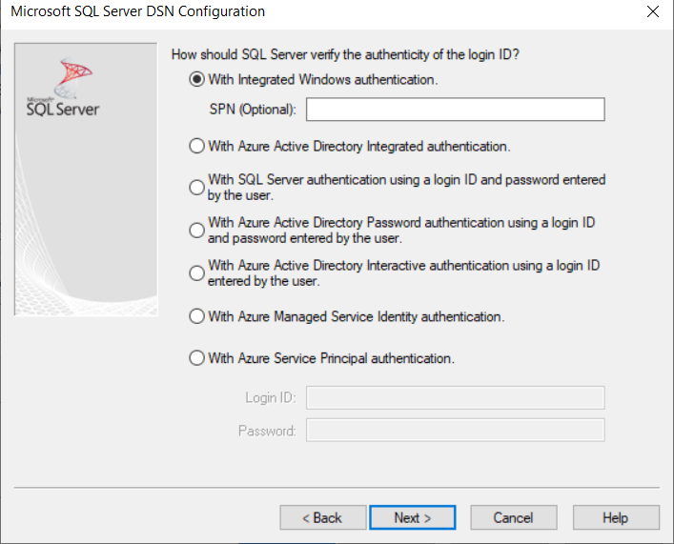

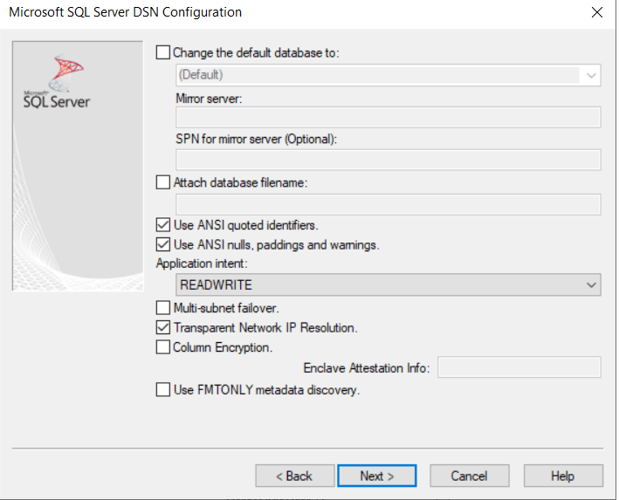

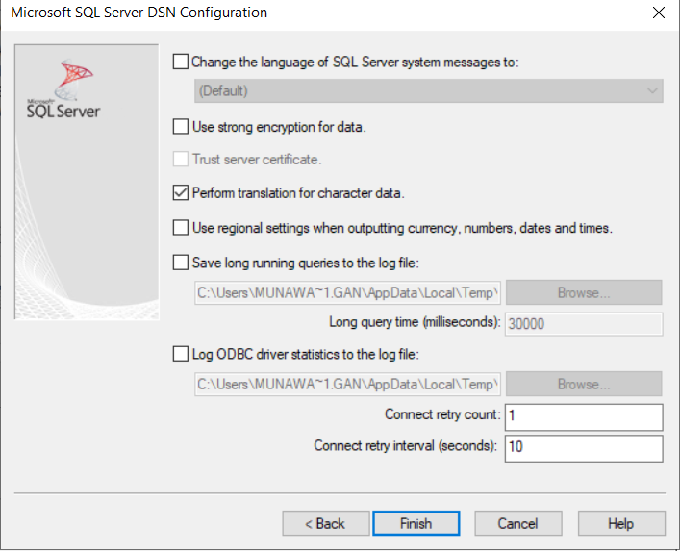

1. Click on “Test Data Source” button to test the connection.

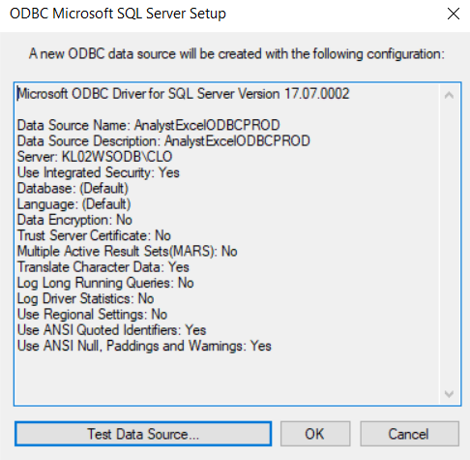

1. Finally click on “OK” button to save the ODBC Data source.

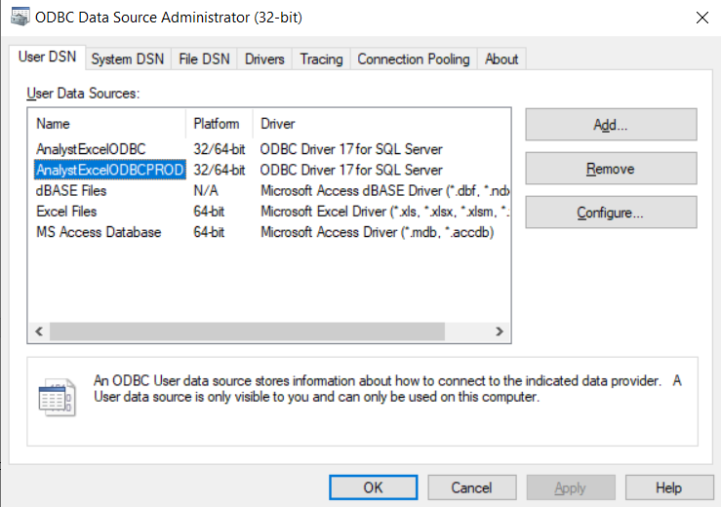

# Steps to setup the connection and fetch data in Excel.

1. Save the ODBC Connection file provided to local machine.



1. Open a new excel workbook.

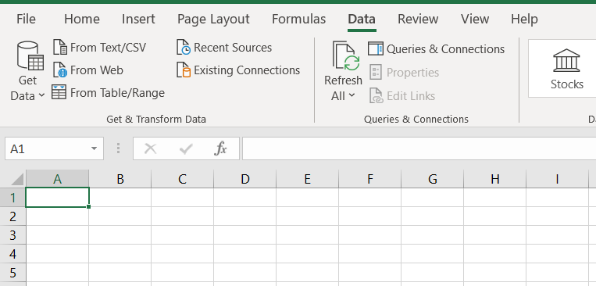

1. Click on “Existing Connections” button on “Data” tab on the ribbon and select the connection file provided.

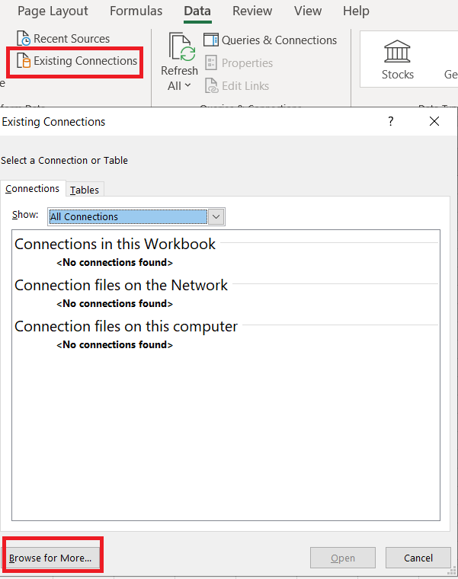

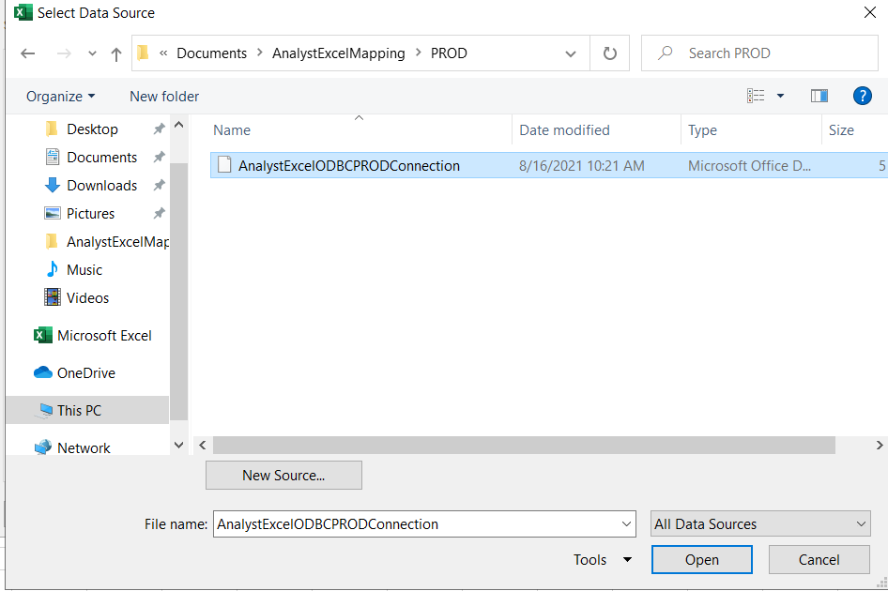

1. After selecting the connection file, the below screen pops up. On click of “OK” button, the data is loaded on the excel sheet. Save the Excel workbook and use it for further needs. The data worksheet can be used as source to create other analysis worksheets in the same workbook.

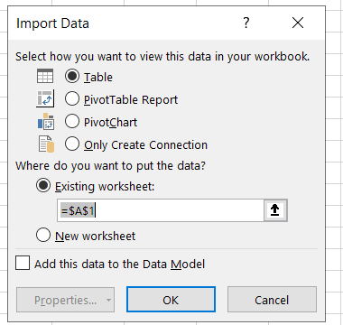

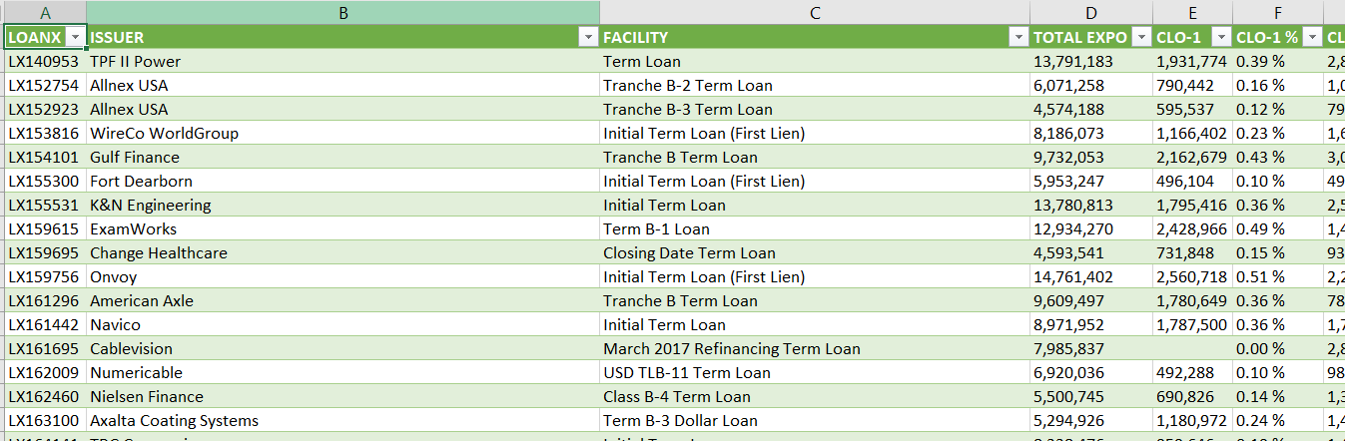

1. For refreshing the data on excel, click on “Refresh All” button on “Data” tab on the Ribbon.

